Squid Dissection

The Squid Dissection program at Hatfield Marine Science Center is designed to be a 50-minute lab-based program for 4th-12th grade students, which examines the external and internal morphology of the California market squid. Students will learn about classification of mollusks then work in pairs, following the directions of their marine educator, to systematically dissect a thawed squid and explore the many adaptations they have for survival in the marine environment.

Background

Squid are invertebrates, meaning they lack a true backbone, in the phylum Mollusca, which includes a variety of organisms including clams, snails, and limpets. They are in the class Cephalopoda (which translated means “head foot”) along with octopus, cuttlefish and nautilus.

Other examples of Mollusks include scallops, nudibranchs, snails, and chitons

Squid are the most highly developed and largest invertebrates on Earth. There are hundreds of different species that are distributed throughout the world’s seas, from the shallowest waters of our coastlines to the deepest portions of the ocean. As juveniles and adults, these creatures are preyed upon by numerous species of fish, birds, marine mammals and even other squid, and form a very important link in oceanic food webs. There is also a large commercial fishery for squid as they are highly prized by humans as calamari and used by recreational fishermen as bait.
Because they are preyed upon by so many other organisms, squid have developed a number of specialized adaptations that help them avoid predators. Squid are highly adept swimmers with several adaptations that allow them to move swiftly through the water. Squid have a siphon that provides jet propulsion and fins to provide stability and direction when swimming. In fact, squid are the fastest swimmers among the invertebrates with some species reaching speeds of up to 25 mph.
Squid also possess chromatophores, specialized structures on their skin which contain pigment and allow them to change color rapidly. These chromatophores can provide camouflage for squid from predators and potential prey, but are also believed to be used for identification purposes and communication between squid. Squid also have an ink sac that can be used to produce a dark cloud in the water, thus confusing predators and allowing squid to make their escape.

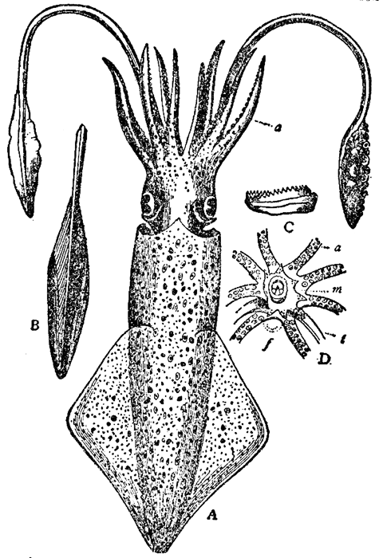

Squid are soft-bodied animals with eight arms and two longer tentacles, all equipped with suckers which are used in feeding. Some species of squid also possess hooks on their appendages thought to be used in defense and feeding.
Although squid lack an external shell, they do have remnants of an internal shell, called a pen because of its unique shape. This shell provides the otherwise soft body of the squid with rigidity and helps maintain body shape.
Like many marine organisms, squid have gills that they use to obtain essential oxygen from water. Unlike most marine organisms however, squid have three hearts. Two of the hearts, the gill hearts, pump blood to the gills to obtain oxygen. The third heart is the systemic heart which pumps the oxygenated blood to the rest of the body.
Squid reproduce sexually with females producing eggs and males producing sperm. Squid go through elaborate courtship displays with males passing sperm packets to the females, who then deposit hundreds of gelatinous eggs on the ocean, often in communal areas. Unlike octopi that guard their eggs after laying them, female squid die shortly after laying their eggs. Research has shown that these eggs are inoculated by the female squid with a host of bacteria that act as a microbial agent to prevent against disease and also seem to deter predators.

Suggested Pre- or Post-Visit Activities and Resources

Have students research the phylum Mollusca. What are the common characteristics of this group? What are the other classes besides Cephalopoda in this phylum? How do they differ from the Cephalopods?

Have students research the size of a giant squid and make a measuring tape that shows the length of arms and tentacles, size of eyes, beak, siphon, etc. Spread out a roll of butcher paper in the hallway and have students create a life-sized giant squid, decorate and label the parts and measurements. Hang in the hallway or cafeteria to share with other students and teachers in the school.

Links to Internet Resources:

Giant Squid Fact Sheet: www.tonmo.com/science/public/giantsquidfacts.php

Make a giant squid pattern and instructions:
http://giantsquid.msstate.edu/LessonList/beanAnimal.html

Build-a-Squid Online Game:
www.squid.tepapa.govt.nz/build-a-squid

Lesson Plans:
www.thecephalopodpage.org
http://www.lamer.lsu.edu/pdfs/SOAR_squid_folio.pdf
http://marinediscovery.arizona.edu/lessonsF00/blennies/2.html

General Cephalopod Information:
http://ngm.nationalgeographic.com/ngm/0408/feature2/index.html
http://gilly.stanford.edu/outreach.html

Images and Video Footage:
www.mnh.si.edu/cephs/cephtaxuf.html
www.tonmo.com

Squid Communication:
http://acp.eugraph.com/cephal/

Squid Reproduction:
http://www-csgc.ucsd.edu/NEWSROOM/NEWSRELEASES/SquidRepro.html

Correlations to Oregon State Science Standards

Grade 4
4.1 Structure and Function: Living and non-living things can be classified by their characteristics and properties.
4.1L.1 Compare and contrast characteristics of fossils and living organisms.
4.2 Interaction and Change: Living and non-living things undergo changes that involve force and energy.
4.2L.1 Describe the interactions of organisms and the environment where they live.

Grade 5
5.1 Structure and Function: Living and non-living things are composed of related parts that function together to form systems.
5.1L.1 Explain that organisms are composed of parts that function together to form a living system.
5.2 Interaction and Change: Force, energy, matter, and organisms interact within living and non-living systems.
5.2L.1 Explain the interdependence of plants, animals, and environment, and how adaptation influences survival.

Grade 6
6.1 Structure and Function: Living and non-living systems are organized groups of related parts that function together and have characteristics and properties.
6.1L.1 Compare and contrast the types and components of cells. Describe the functions and relative complexity of cells, tissues, organs, and organ systems.
6.2 Interaction and Change: The related parts within a system interact and change.
6.2L.1 Describe the relationships and interactions between and among cells, tissues, organs, and organ systems.
6.2L.2 Explain how individual organisms and populations in an ecosystem interact and how changes in populations are related to resources.

Grade 7
7.1 Structure and Function: Living and non-living systems are composed of components which affect the characteristics and properties of the system.
7.1L.1 Compare and contrast sexual and asexual reproduction. Explain why reproduction is essential to the continuation of every species.

Grade 8
8.1 Structure and Function: Systems and their components function at various levels of complexity.
8.1L.1 Explain how genetics and anatomical characteristics are used to classify organisms and infer evolutionary relationships.

